Lab

Inheritance



Lab: Inheritance

Objective
The main goal of this lab is to help you develop the ability to create new types by extending existing ones, while also incorporating specialised functionality to meet specific requirements.

Overview
This lab introduces the foundational concepts of inheritance. As discussed in the accompanying session, implementing inheritance requires an initial class that defines the core behavior or functionality to be extended.

Step-by-step
- Open the Labs project and then add a new package called lab7.
- Write a class called Program with a main() method in the lab7 package.
- Create the following class structure:
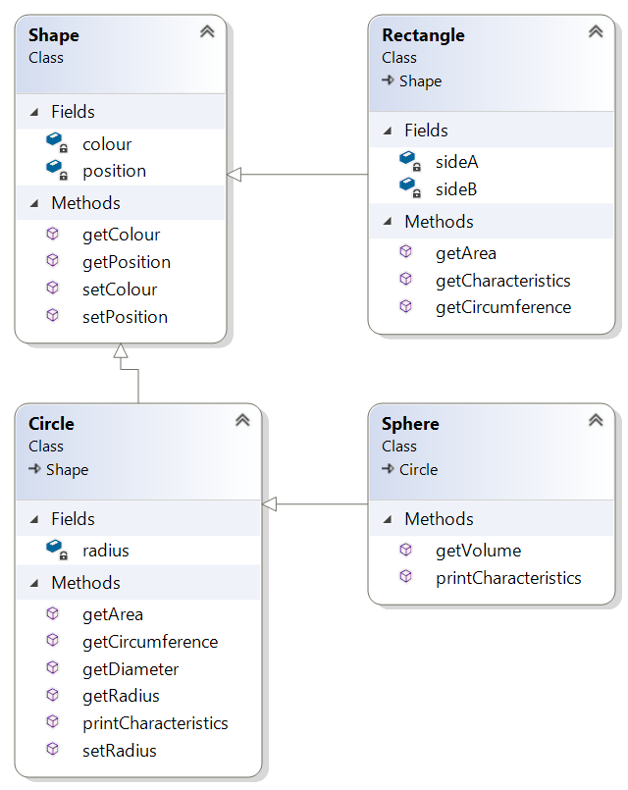
- Create a constructor for Shape to set its colour and position.
- As you can see, Circle extends Shape and Sphere extends Circle.
  - Position is of type Point which is a class with built-in x and y.
Tip: import java.awt.Point
  - Colour is of type java.awt.Color
You will use Math.PI to get the value of PI which you’ll use to calculate the area and circumference of a circle.
Volume of a sphere is calculated as 4/3 * PI * R * R * R
You can use the Math.pow(R, 3) function or R * R * R
- Create getters and setters for each field (colour, radius, etc.) as indicated in the class diagram above.
- The getCharacteristics() method returns a String containing all the attributes of the shape. It will be up to the caller how to display this information.
- Create different kinds of shapes in main() like Rectangle, Circle, and Sphere.
- Print the characteristics of these objects.
- Create an ArrayList<Shape> called shapes in the main().
- Add the shapes which you created earlier into the shapes ArrayList.
- Create an enhanced for loop to scroll through each shape and print its colour and position (x and y).
How does this work?
How can we store a shape, like a Rectangle, in a list of Shape objects?
This will be answered in the next chapter where you’ll discover how object-oriented principles make this possible.

** End **



